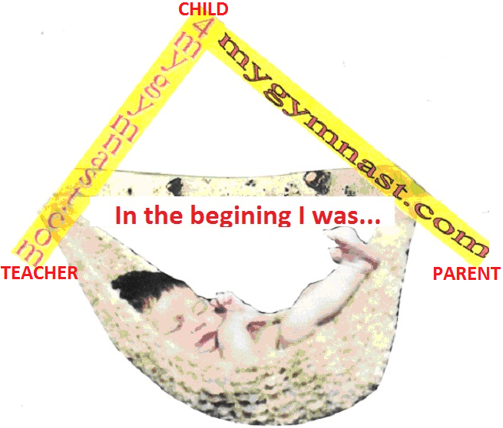By: Marco and Pintack Gualotuña:
This book was created in cooperation with Computers in Education, http://4gymnast.com, acrobatic, artistic, rhythmic, T&T, cheer and ballet media. Edited by Pintack and Marco Gualotuňa. All information on this page and the subsequent pages is copyrighted by Computers in Education; the data may not be copied, not modified, or taken without the express written permission of that party. Images contained herein may or may not be copyrights of the aforementioned company. In the case of shared copyright, no attempt to change these images is implied nor intended to alter them. Any questions should be mailed to m2educate@hotmail.com or 310425-4292.
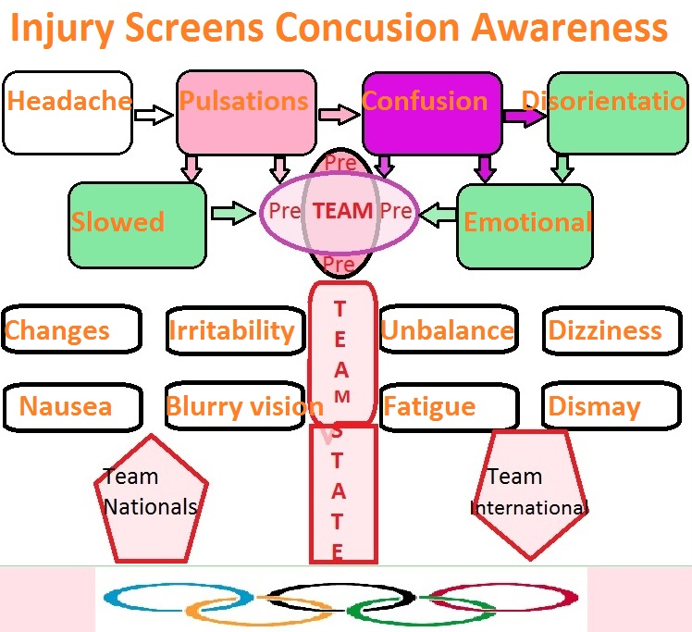
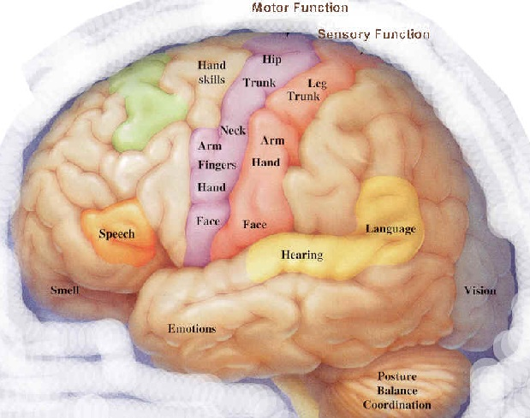

BRAIN FUNCTIONAL SYSTEM IS CONTROL BY EMOTIONS
The function of the brains is to learn, but learning is control by many variables, one of them is our surroundings or our environment. Learning is done in a simple mechanical manner: our cerebrum is the permanent memory, the cerebellum is our auxiliary or temporally memory, the neurons are the transient memory, our hypothalamus is our bios memory and our five senses are the collectors of information. Information is capture by one of our five senses and that information travels to our cerebellum, from the cerebellum the neurons pick up the information and travel trough the spinal fluid to the different parts in the cerebrum were is collected process and store for later used. Now the speed at which each of us learn, whether a child or an adult, our learning depends on the efficiency of the lines of communication were information travels, but this lines are efficient and wide open when we are happy, and learning take place in a short time. The lines of communication are struck or close when we are sad or worried, than the time with which a person learns is longer.
As a teacher, a gymnast, a coach and a parent I observed this simple equation and train my students observing these simple rules. To enhance the gymnast learning ability by using their network of communications with all memories and make learning an easy function, I form a playful environment so my gymnast are engage completely in the sport. Brain Gymnastics is based on three simple principals; learning is a natural and enjoyable activity that continues throughout life, learning difficulties is control by stress and doubt slows down the learning of a new task. I used learning difficulties as a fuel to enhance learning, not as a detriment experience to stop learning. Generally, we accept the limitations in our lives as something inevitable and also we discover the benefits of positive stress. Brain gymnastics is a natural alternative to a healthy training that deals with tensions and challenges of the athletes. The main exercises movement crossed the center line, the gymnast move to the left and right different parts of the body by passing through the center of the body. This movement helps integrate vision with both eyes, hearing with ears as well as left and right sides of the brain and body. This are some of the movement in the opposite hand and foot in various directions; Touch the opposite leg through the back of the body.- Do slowly cross motion, motion in the opposite hand and leg to limit the maximum reengaging, The movement started first left hand to activate the right side of brain- Movement of the hand starting from the midpoint towards the top left, bottom left circle to go up to the middle point to the right again and continue on, turning into the bottom right, back to the mid-point, and so on. The eyes follow the 8 do three times for each hand and also three times for both hands together. In the classroom as well in the gym or park the opposite movements of the body help us to train our brains in such manner that the most sophisticated moves in gymnastics or acrobatics can be accomplished.
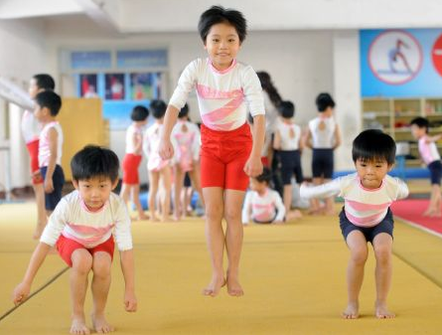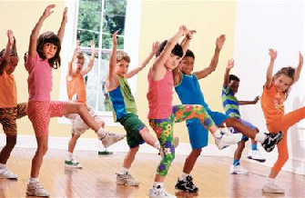

F: ___ _ _
S: _____ _
Pointe
C: ___ ___
P: _____ __
D: ___ ____
T: ___ ___
A: _____ __
S: ___ __ __
H: ___ _
R: _____ __
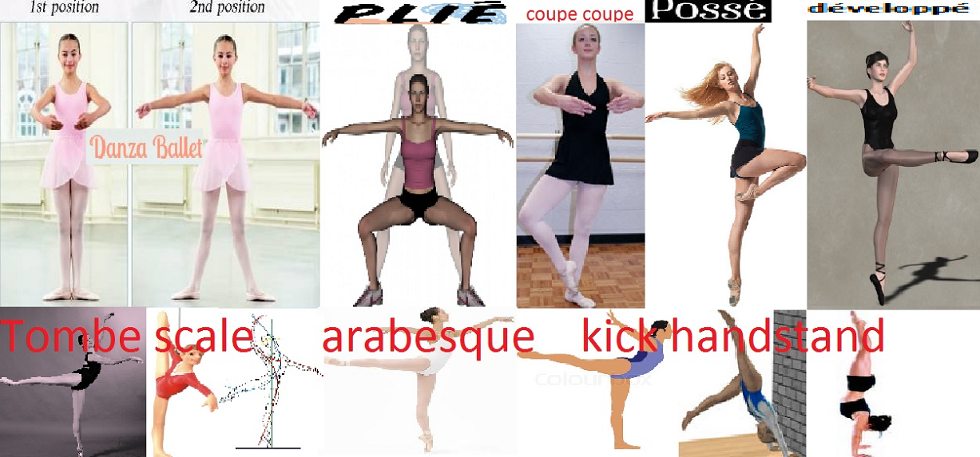
Table
Ta-dal
2: Pike
Push up
Puck up
3: Tuck
Knee scale
Kicks
Lunge
Straddle
Scale
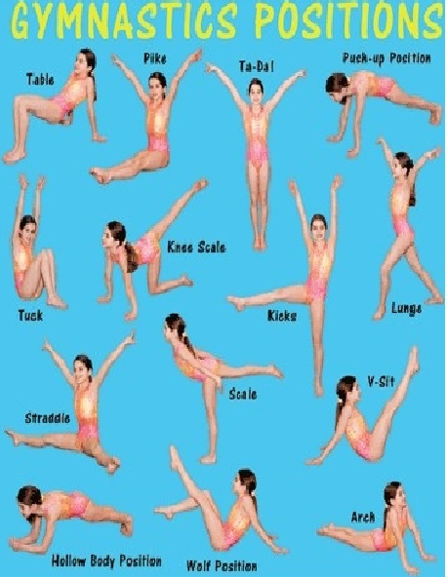

Fold
Squad
Tuck
Roll front
Roll back
Log roll
Triangle
Table
Bridge
Tuck
Stand

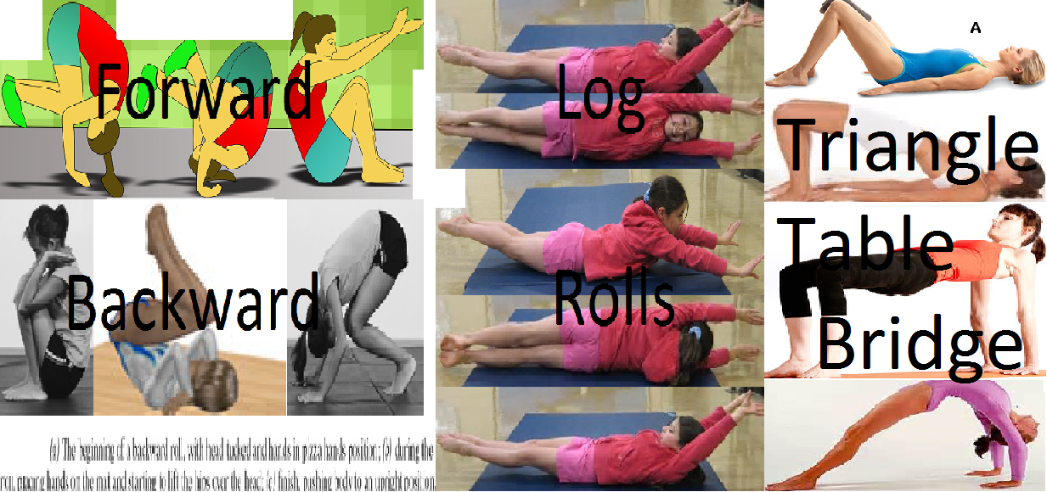
Handstands
Pike press
Seat
V up
Puck up
Squad
Tuck
Roll
Front
Back
Straddle
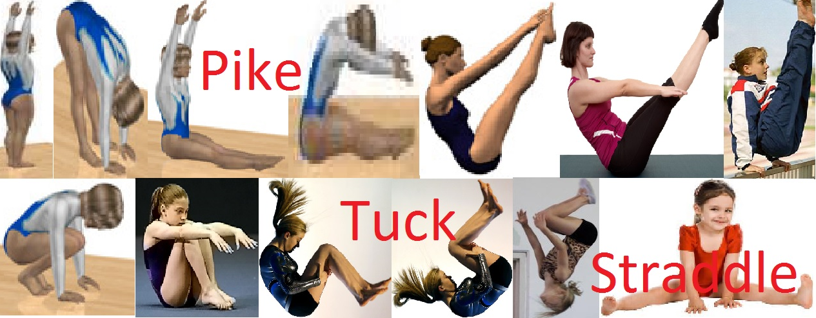

Roll
Front
Back
Straddle
Seat
Pike
Straddle
Press
Tuck
Press
Splits
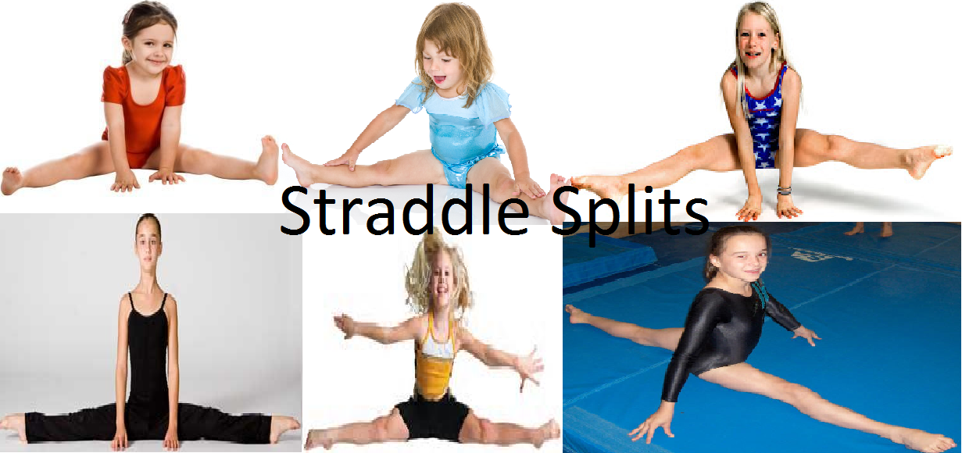

Rope
Dove
Ribbon
Spirit
Ball
Needle
Clubs
Limber
Hoop
Rolls
Toss
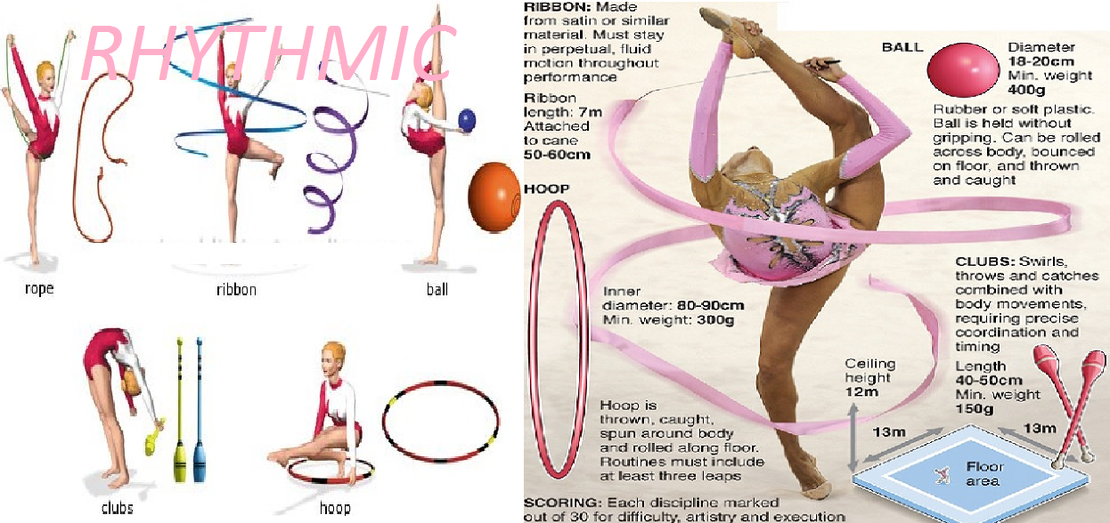

T H touch
Tactic scale
Elbow stand
4: Straddle
5:Toe touch
Handstand
7: Flier _
Press
Elbow arch
Reverse pike
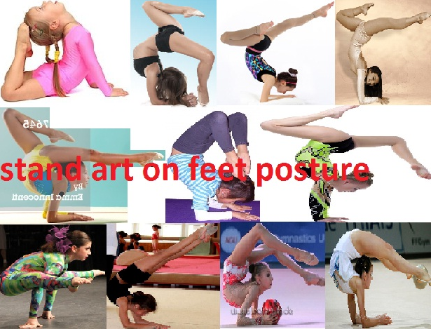
Lunge
Scale kick
Stand
Straddle
Stand arch
6: Base ___
Handstand
8: Support
9: Stunt __
0: Routine
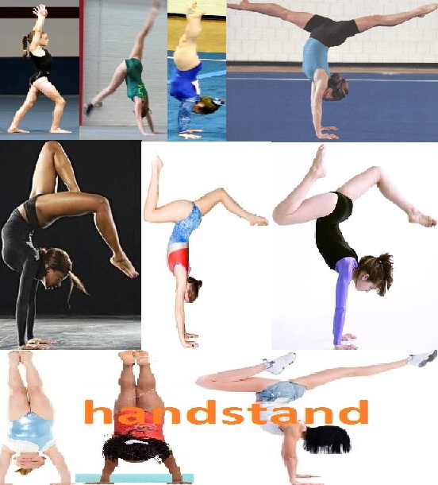
F: ___ _ _
S: _____ _
Pointe
C: ___ ___
P: _____ __
D: ___ ____
T: ___ ___
A: _____ __
S: ___ __ __
H: ___ _
R: _____ __
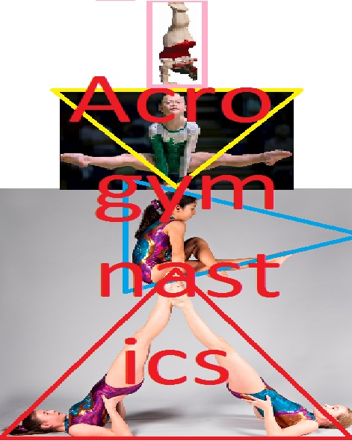

Eagle jump

Toe touch
Hurdler

Front

Side
Pike
Tuck
Hook
Herkie
Double 9
Liberty
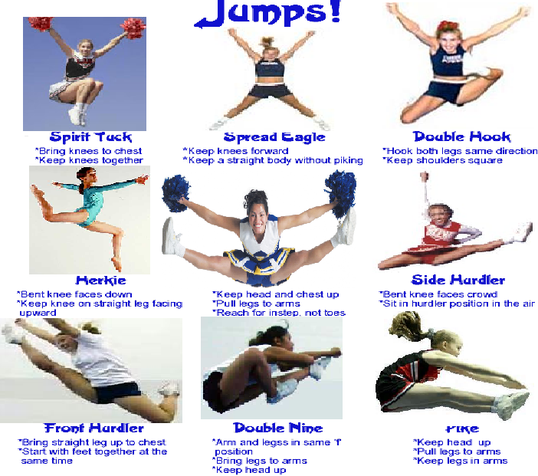

Pike
Tuck

Straight

Side
Flittus
Quadrittus
Front
Back
somerfsault
Liberty
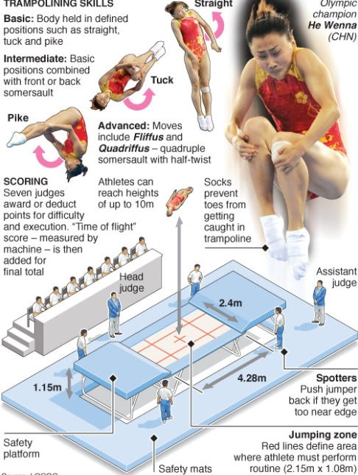
Sad
Crying
Rude
Upset
Sweating
Nervous
Fail senses
Stop
Danger
Accident

F1. Fail to know what is 2 teach? Please!
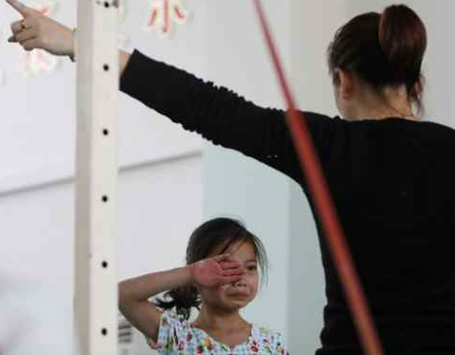
Sad
Crying
Rude
Upset
Sweating
Nervous
Fail senses
Stop
Danger
Accident
F1. This is not fun or constructive gymnastics score?
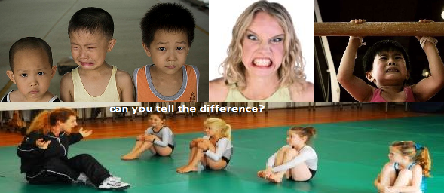
Sad
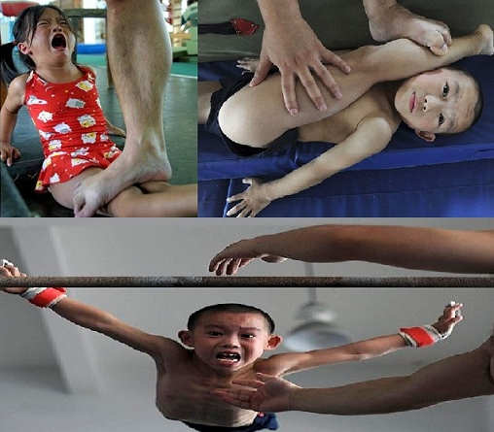
Crying
Rude
Upset
Sweating
Nervous
Fail senses
Stop
Danger
Accident

W1. Bad experience a move that scores .00!

Sad
Crying
Rude
Upset
Sweating
Nervous
Fail senses
Stop
Danger
Accident

F1. This is not fun or constructive gymnastics or teaching?
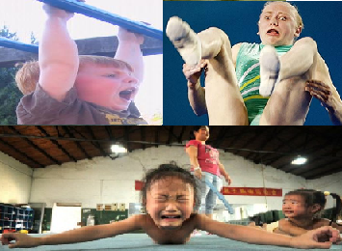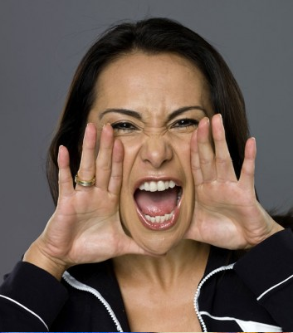

Safety
Coaching
Teaching
Training
Caring
Leading
Practicing
Performing
Safety
No accidents

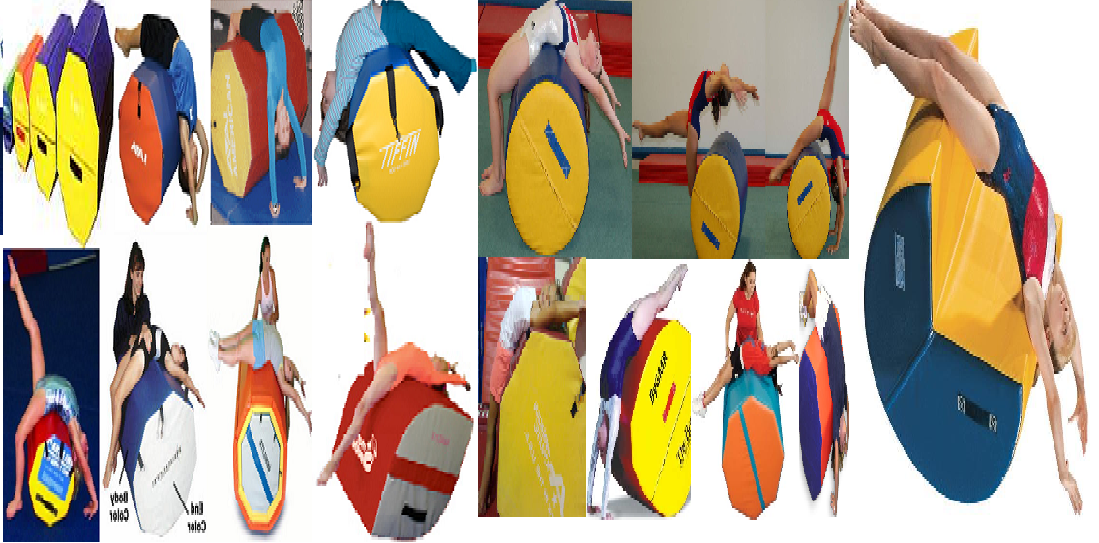
Safety
Coaching
Teaching
Training
Caring
Leading
Practicing
Performing
Safety
No accidents
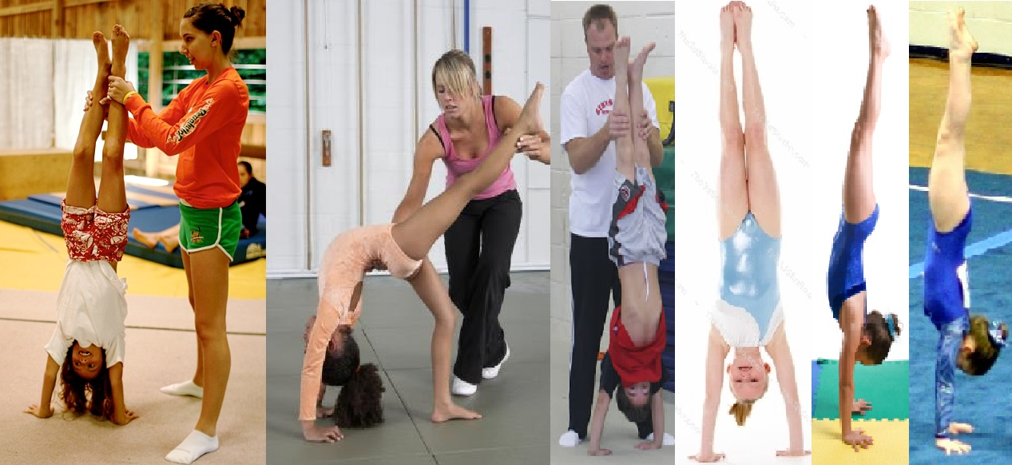

Safety
Coaching
Teaching
Training
Caring
Leading
Practicing
Performing
Safety
No accidents
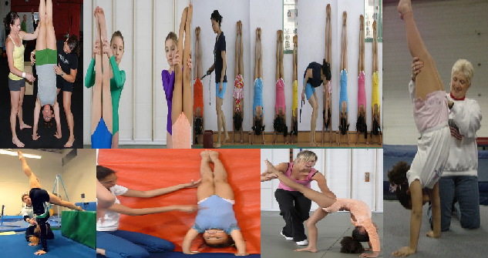

Sad
Crying
Rude
Upset
Sweating
Nervous
Fail senses
Stop
Danger
Accident
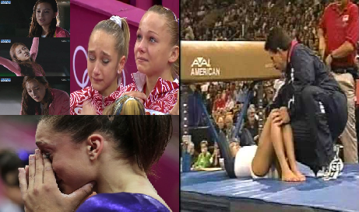

PRESCHOOL
60”
Literacy
Math
60”
Gym
30”
Science
30”
Life skills
30”
Ms. Miranda
BALLET
First
second
Pointe
C: ___
P: ___
D: __
T: ___
A: ___
S: ___
R
Ms. Courtney
WAG

Pike
Tuck_
Straddle
Splits
Table

Bridge

Kick over
Walk ver
Front roll
Back roll
Ms. Cassidy
WRG
Leap__

Splits
Tuck__
Pike
Scale

Walk

Roll
HS
Bridge
Cartw
Mr. Marco
ACROG
Ballet _
Wag
Wrg
Cheer
Pirouette
Routine
P/T/S:
Table:
Bridge:
Press:
Mr. Marco
CHEER
Jump
Pike
Tuck
Straddle
Toe ouch
Liberty
Eagle
Herkie
Hook
Hurdler
Jessica/Griffin
T&T
Jump
Pike
Tuck
Straddle
Seat
Stand
Pike
Tuck
Straddle
Drop

M. ARTS
White
Yellow
Orange
Purple
Green
Blue
Brown
Red
Black
1 Dan
Ms. Sam

YOGA
D Dog
Cat
Warrior A
Warrior B
Sun
Tree
Camel
Bow
Dolphin
B. bridge
Donell

PRESCHOOL
60”
Literacy
Math
60”
Gym
30”
Science
30”
Life skills
30”
Ms. Miranda

BALLET
F: ___
S:____
Pointe
C: ___
P: ___
D: __
T: ___
A: ___
S: ___
R
Ms. Courtney

WAG

Pike
Tuck_
Straddle
Splits
Table

Bridge

Kick over
Walk ver
Front roll
Back roll
Ms. Cassidy

WRG
Leap__

Splits
Tuck__
Pike
Scale

Walk

Roll
HS
Bridge
Cartw
Mr. Marco

ACROG
Ballet _
Wag
Wrg
Cheer
Pirouette
Routine
P/T/S:
Table:
Bridge:
Press:
Mr. Marco

CHEER
Jump
Pike
Tuck
Straddle
Toe ouch
Liberty
Eagle
Herkie
Hook
Hurdler
Jessica/Griffin

T&T
Jump
Pike
Tuck
Straddle
Seat
Stand
Pike
Tuck
Straddle
Drop

M. ARTS
White
Yellow
Orange
Purple
Green
Blue
Brown
Red
Black
1 Dan
Ms. Sam

YOGA
D Dog
Cat
Warrior A
Warrior B
Sun
Tree
Camel
Bow
Dolphin
B. bridge
Staff

Hands
Toes
Phalanges
Metatarsus
Tarsal
Calcareous
Joints
Press
Palmer
Tendons
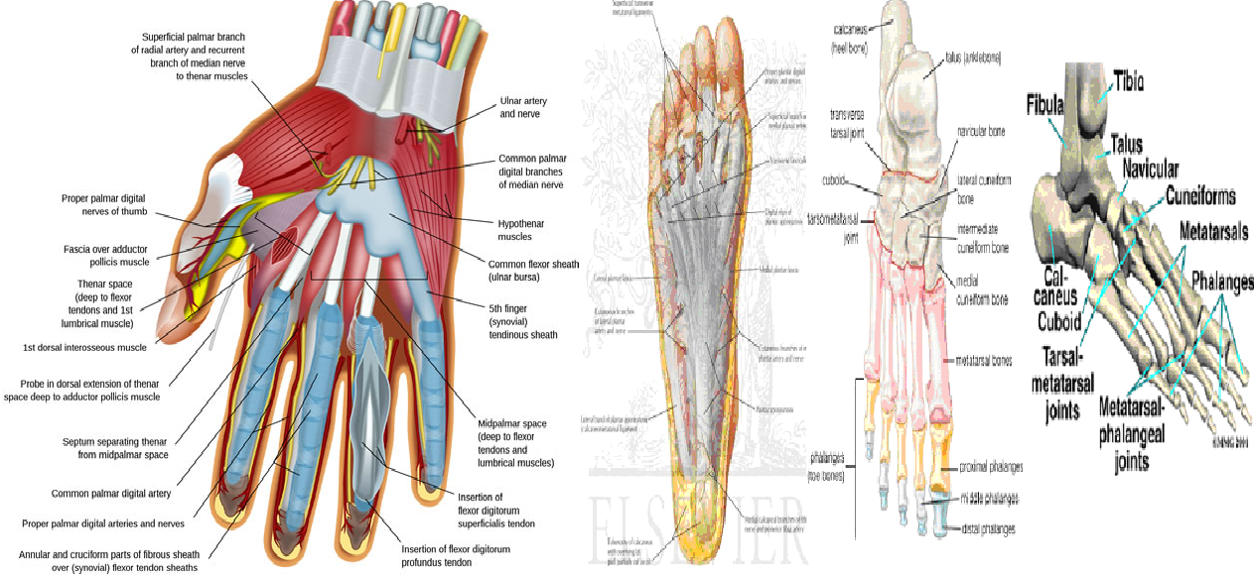
Lumber
7 cervical
12 thoracic
5 lumber
5 sacral
4 coccyx’s
Disc
Normal
Degenerated
Bulging
Herniated
Degeneration
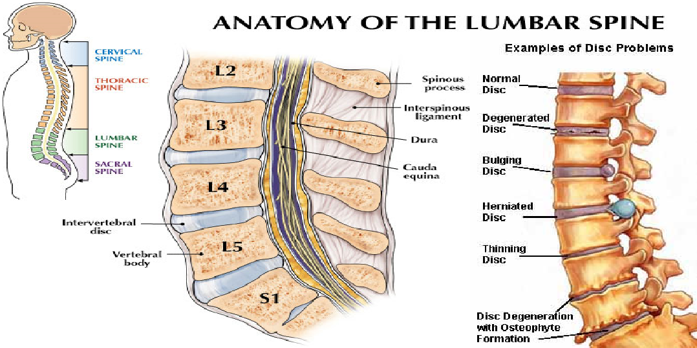Ball

Lumber
7 cervical
12 thoracic
5 lumber
5 sacral
4 coccyx’s
Disc
Normal
Degenerated
Bulging
Herniated
Degeneration
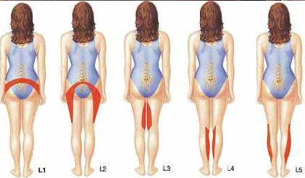

Lumber
7 cervical
12 thoracic
5 lumber
5 sacral
4 coccyx’s
Disc
Normal
Degenerated
Bulging
Herniated
Degeneration

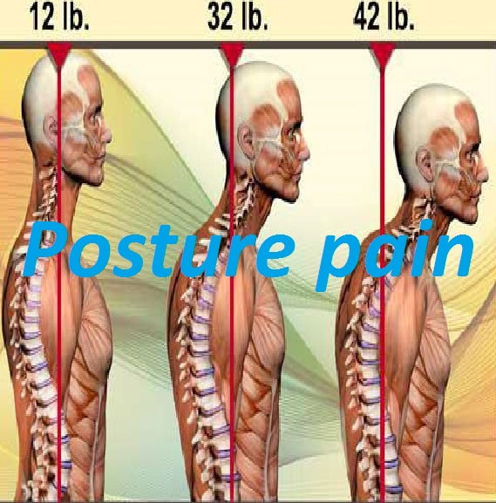

Hands
Toes
Phalanges
Metatarsus
Tarsal
Calcareous
Joints
Press
Palmer
Tendons
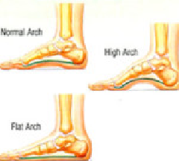

Training
Review
Anatomy
Brains
Spinal
Hands
Feet
Rolls
Bridges
Ballet
Wam

Ms. Miranda

Engage
On time
Prepare
Check
Greed
Enjoy
Direct
Be alert
Divide
Release
Clean
Ms. Staff

Inquire
Ask
Read
Practice
Eat well
Sleep
Groom
Handle
Show
Safe
Close
Ms. Cassidy

Incident
Incident
Tell
Observe
Help
Accord
Balance
Gossip
Served
Served
Served
Mr. Marco

Do not
Seat
Interrupt
Clutter
Fall
Break
Drink
Chew
Sleep
Snore
Spit
Mr. Marco

Do not
Yell
Pull
Drop
Say no
Eat
Drink
Chew
Fall
Ignore
Seat
Jessica/Griffin

Do not
Yell
Pull
Drop
Say no
Eat
Drink
Chew
Fall
Ignore
Seat

Do not
Yell
Pull
Drop
Say no
Eat
Drink
Chew
Fall
Ignore
Seat
Ms. Sam

Do not
Yell
Pull
Drop
Say no
Eat
Drink
Chew
Fall
Ignore
Seat
Staff

Math
Ballet
Relevé
Wag
Aerials
Wrg
Pirouette
Cheer
Liberty

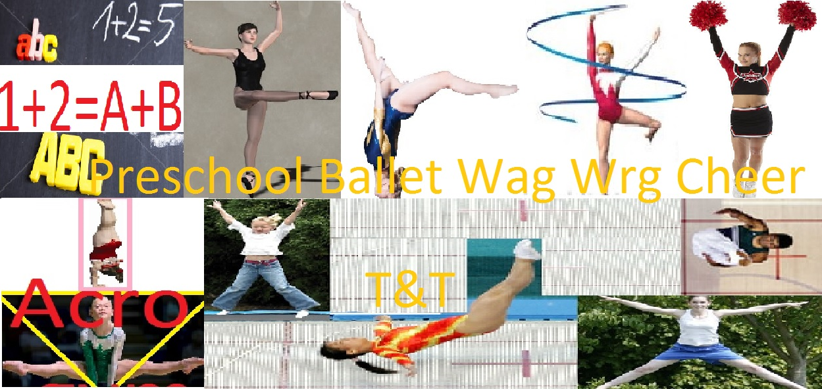
60 minutes
Literacy
Math
60 minutes
Gym n learn
30 minutes
Science
30 minutes
Cognitive
Skills



